OPEN POD SYSTEMS ARE BECOMING POPULAR WITH YOUTH
Data from the 2019 National Youth Tobacco Survey, published in JAMA, found that after Juul, Suorin and Smok are the most popular e-cigarette devices among high school students. 7.8% of high school e-cigarette users reported using Suorin and 3.1% reported using Smok. These prevalence estimates are solely from write-in responses, since Suorin and Smok were not listed as options in the questionnarie, so actual use rates are likely higher.
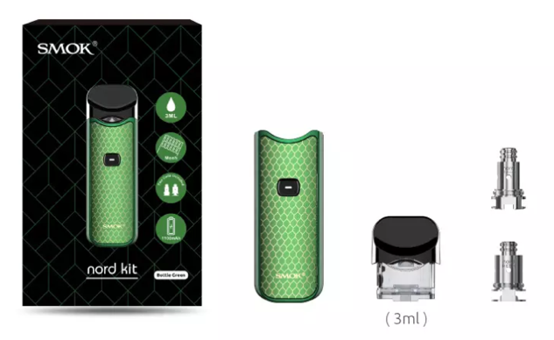
Both Suorin and Smok are open pod systems. Unlike Juul, which sells pre-filled, closed cartridges, Suorin and Smok devices come with empty, refillable pods which can be filled with e-liquids of varying nicotine strengths and flavors.

Smok nord device and refillable pod
https://www.smoktech.com/

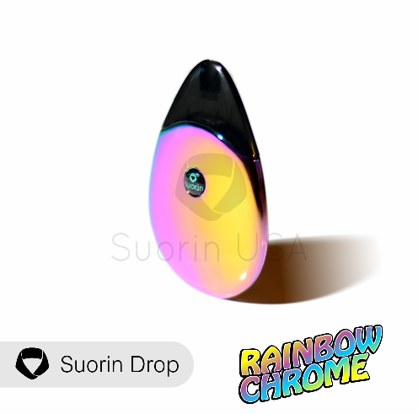

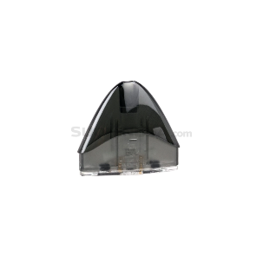

Suorin Drop device and refillable pod
https://www.suorinusa.com/
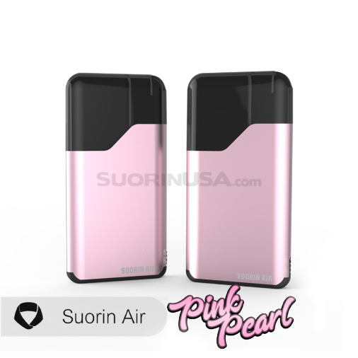
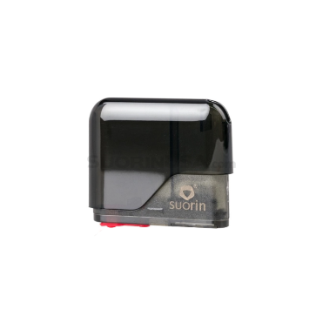
Suorin Air device and refillable pod
https://www.suorinusa.com/

Cullen, KA, et al., “e-Cigarette Use Among Youth in the United States, 2019” JAMA, published online November 5, 2019.

